

**College of Computing**

**Department of Software Engineering**

**Big Data individual assignment**

**Course Code: SENG5112**

**Course Title: Fundamental of Big Data Analytics and Business Intelligence**

**Done by: Beimnet Wesley**

**Submitted to: Mr.Abebe**

Table of Contents

**Introduction** 3

**1. Data Extraction:** 3

**2. Data Transformation:** 3

**2.1 Handling Missing Values:** 3

**2.2** **Removing Duplicates:** 3

**2.3** **Replacing Dots with Spaces in Specific Columns:** 4

**2.4** **Converting Timestamp Format:** 4

3. Data Loading: 4

**3.2 Data Insertion into DuckDB:** 5

**4. Data Export:** 5

**4.1 Export Data to Parquet:** 5

**5. Data Analysis and Visualization with Plotly:** 5

**5.1 Sales by Brand:** 5

**5.2 Price vs. Sales by Category:** 6

**5.3** **Product Category Share:** 7

**5.4 Customer Segmentation by Spending:** 8

**5.5** **Sales Trend Over Time:** 9

**6. Power BI Integration:** 10

# **Introduction**

This documentation provides a comprehensive overview of the ETL pipeline used to transform, load, and analyze e-commerce data. The pipeline extracts raw data from a CSV file, processes it using Spark for transformation, and stores the results in a DuckDB database. Finally, it visualizes the data using Plotly and integrates it into Power BI for analysis.

# **1. Data Extraction:**

The raw e-commerce data is loaded from a CSV file into a PySpark DataFrame. This step initiates the extraction of information, including product details, user behavior, and transaction data.

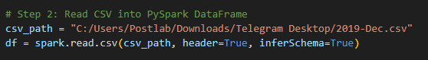

* **Path to CSV**: The location of the CSV file is specified (csv_path).
* **Data Loading**: The spark.read.csv() function is used to read the CSV file into a DataFrame with inferred data types and headers.

# **2. Data Transformation:**

## **2.1 Handling Missing Values:**

To ensure data quality, rows with missing values are removed from the DataFrame.

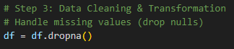

## **2.2** **Removing Duplicates:**

Any duplicate rows are removed to avoid redundant data processing and storage.



## **2.3** **Replacing Dots with Spaces in Specific Columns:**

To clean the data, dots in certain columns are replaced with spaces. This is done in columns like event_type, category_code, brand, and user_session to standardize the text fields.

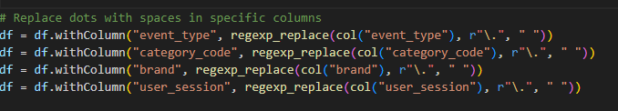

## **2.4** **Converting Timestamp Format:**

The **event_time** column is converted from string format to a timestamp format, which allows for better time-series analysis and processing.



### ****3. Data Loading:****

#### 3.1 ****Loading Data into DuckDB:****

The cleaned and transformed data is loaded into a DuckDB database for further analysis. 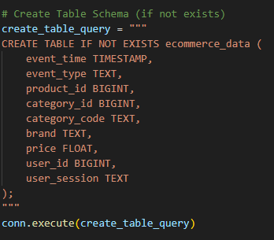

* **Schema Design**: The schema design ensures that all relevant columns (e.g., product ID, category, price, user information) are properly defined.
* **Table Creation**: A query is executed to create a table if it doesn't already exist in the database.

## **3.2 Data Insertion into DuckDB:**

The transformed data (in Pandas format) is inserted into the DuckDB table for persistent storage.

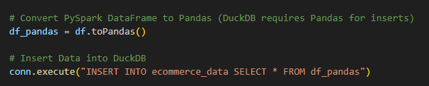

# **4. Data Export:**

## **4.1 Export Data to Parquet:**

The data is exported to a Parquet file for further use in BI tools like Power BI and Tableau.

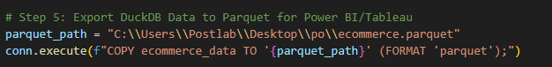

# **5. Data Analysis and Visualization with Plotly:**

## **5.1 Sales by Brand:**

A bar chart is created to visualize the total sales by brand. This helps to identify top-performing brands.

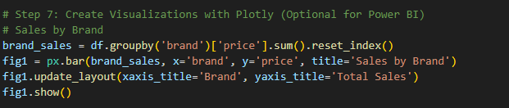

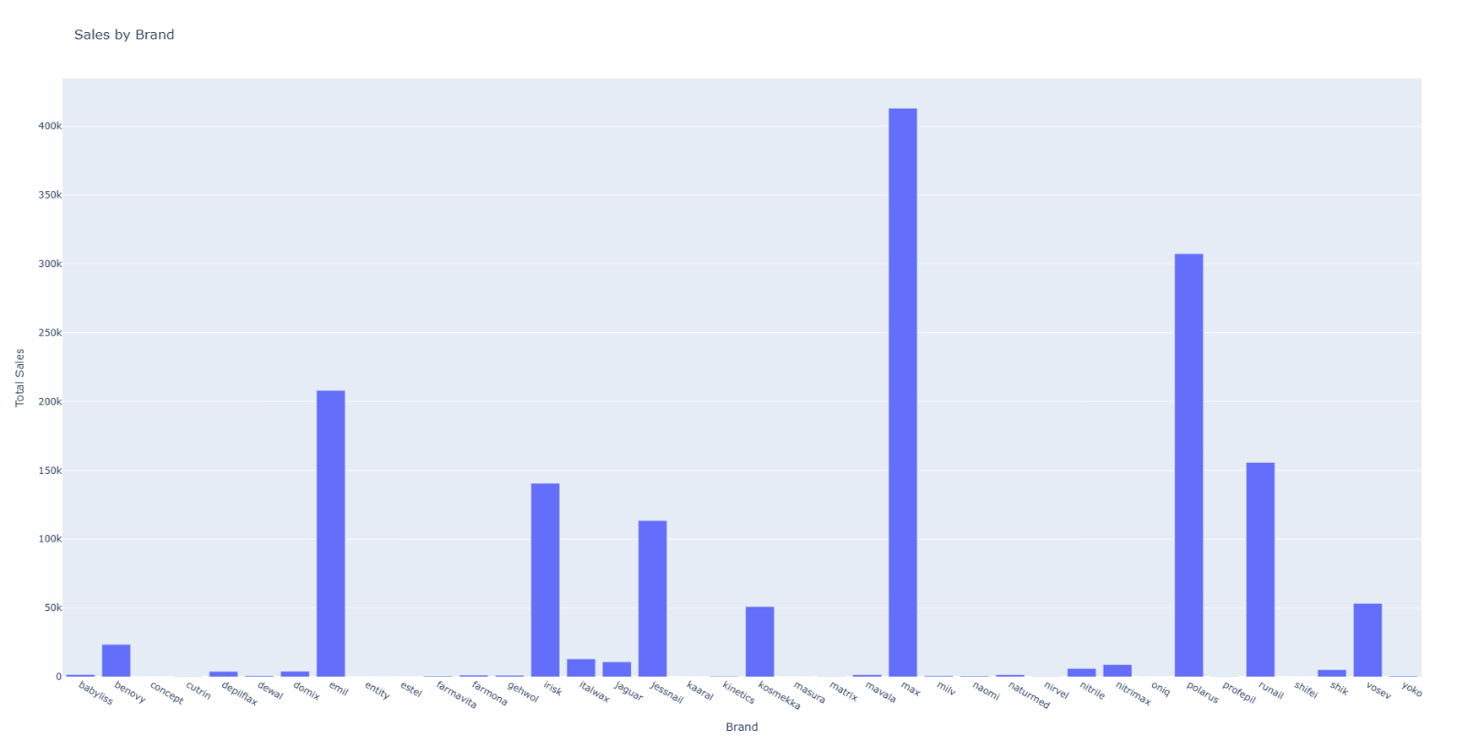

## **5.2 Price vs. Sales by Category:**

A scatter plot shows the relationship between price and sales for each category.



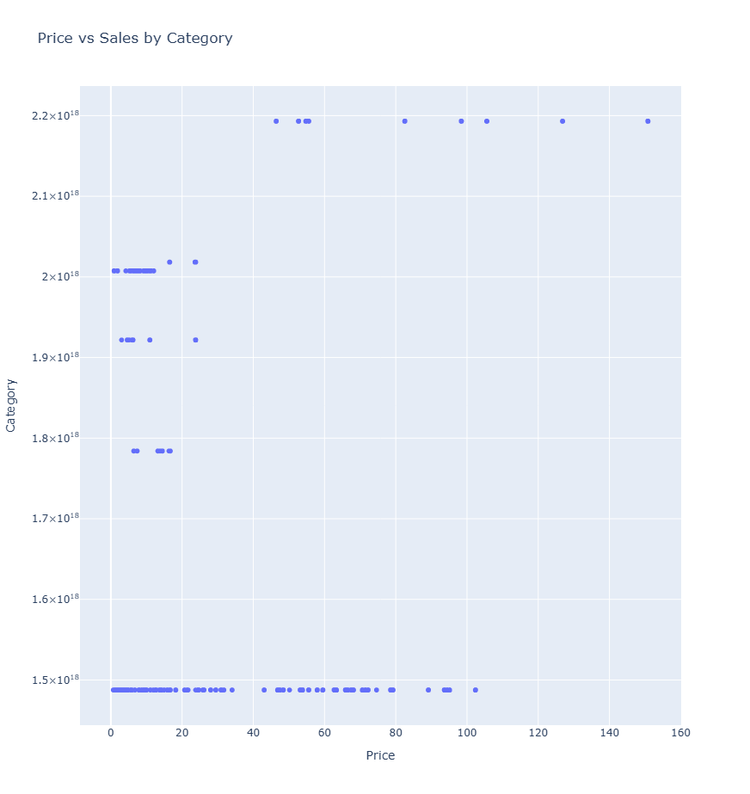

## **5.3** **Product Category Share:**

A pie chart is used to represent the share of total sales by product category.

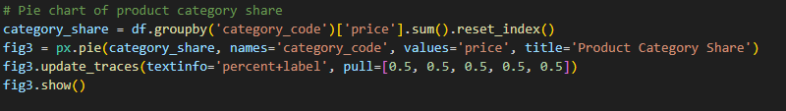

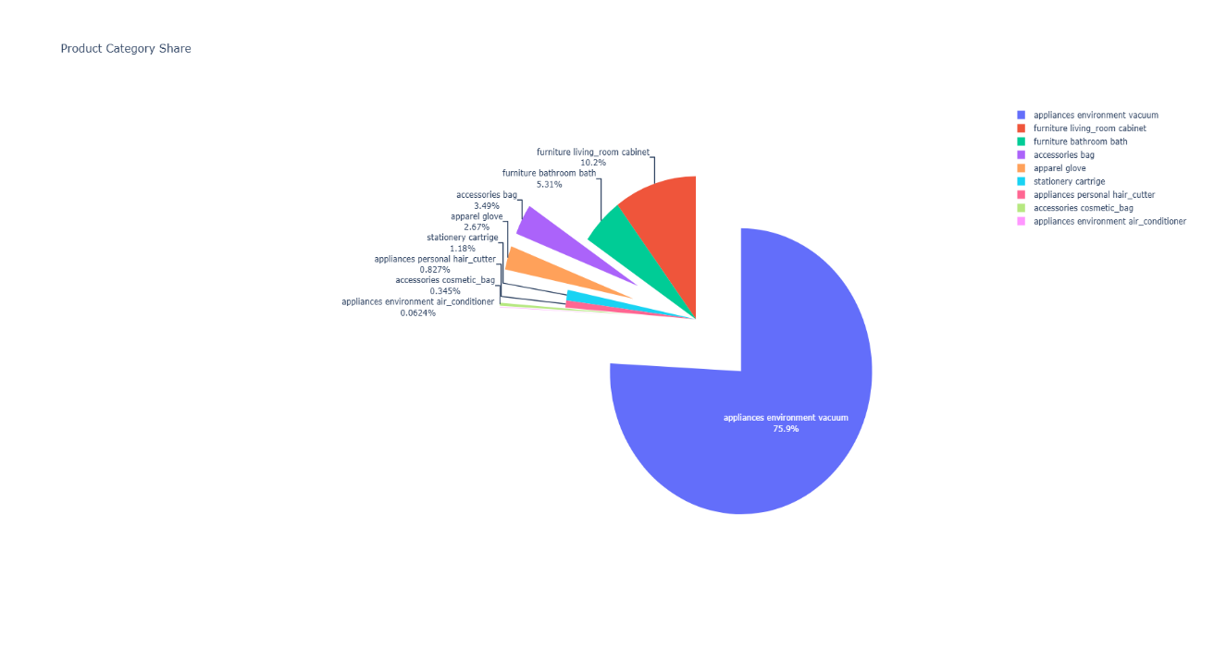

## **5.4 Customer Segmentation by Spending:**

A histogram visualizes the distribution of customer spending.



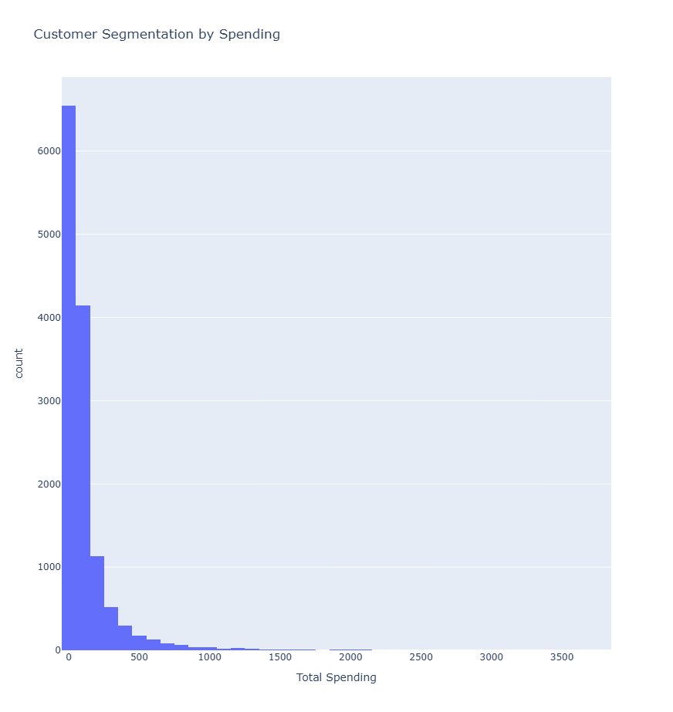

## **5.5** **Sales Trend Over Time:**

A line chart visualizes sales trends over time, helping to identify any seasonality or patterns.

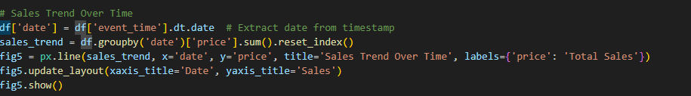

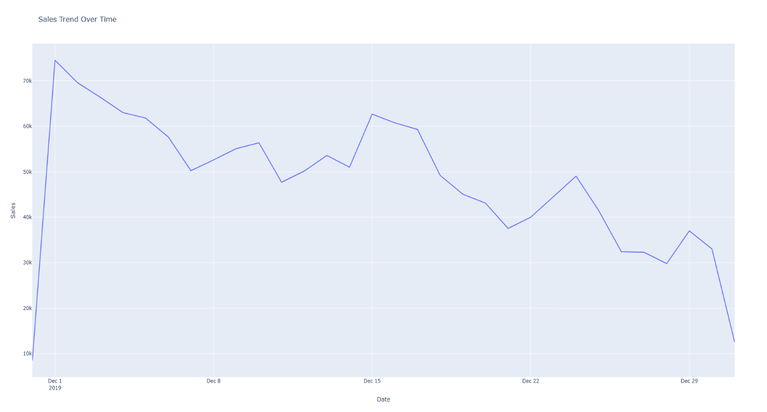

# **6. Power BI Integration:**

#### 6.1 ****Load Data into Power BI using Python Script:****

To visualize data within Power BI, you can use a Python script to load data directly from DuckDB. This ensures that the latest data is always available.

